**DBMS LAB 2**

**PROGRAM 2: BANKING ENTERPRISE DATABASE**

Consider the following database for a banking enterprise.

BRANCH (branch-name#: string, branch-city: string, assets: real)

ACCOUNTS (accno: int, branch-name: string, balance: real)

DEPOSITOR (customer-name#: string, customer-street: string, customer-city: string)

LOAN (loan-number#: int, branch-name: string, amount: real)

BORROWER (customer-name: string, loan-number: int)

* 1. Create the above tables by properly specifying the primary keys and the foreign keys

**create table BRANCH**

**(**

**branch_name varchar(60),**

**branch_city varchar(60),**

**assets real,**

**primary key(branch_name)**

**);**

**create table ACCOUNTS**

**(**

**accno int,**

**branch_name varchar(60),**

**balance real,**

**primary key(accno,branch_name),**

**foreign key(branch_name) references BRANCH(branch_name)on delete cascade on update cascade**

**);**

**create table DEPOSITOR**

**(**

**customer_name varchar(60),**

**accno int,**

**primary key(customer_name,accno),**

**foreign key(accno) references ACCOUNTS(accno)on delete cascade on update cascade**

**);**

**create table CUSTOMER**

**(**

**customer_name varchar(60),**

**customer_street varchar(60),**

**customer_city varchar(60),**

**primary key(customer_name),**

**foreign key(customer_name) references DEPOSITOR(customer_name)on delete cascade on update cascade**

**);**

**create table LOAN**

**(**

**loan_number int,**

**branch_name varchar(60),**

**amount real,**

**primary key(loan_number,branch_name),**

**foreign key(branch_name) references BRANCH(branch_name)**

**);**

**create table BORROWER**

**(**

**customer_name varchar(60),**

**loan_number int,**

**primary key(customer_name,loan_number),**

**foreign key(customer_name) references DEPOSITOR(customer_name) on delete cascade on update cascade,**

**foreign key(loan_number) references LOAN(loan_number) on delete cascade on update cascade**

**);**

* 1. Enter at least 5 tuples for each relation.

**insert into BRANCH values**

**('ICICI','DHARWAD',50000),**

**('SBI','BANGALORE',45000),**

**('SBI-BASVANGUDI','BANGALORE',37000),**

**('ALLAHABADH','HUBLI',15000),**

**('KARNATAKA-BANK','BELGAUM',90000);**

**insert into ACCOUNTS values**

**(12345,'ALLAHABADH',4000),**

**(67890,'SBI-BASVANGUDI',7500),**

**(34567,'KARNATAKA-BANK',9000),**

**(12389,'ICICI',5600),**

**(49389,'ICICI',1780),**

**(34567,'ICICI',5000);**

**insert into DEPOSITOR values**

**('KRISHNA',12345),**

**('RADHA',12389),**

**('BALRAM',34567),**

**('AKSHAY',49389),**

**('PALLAVI',67890),**

**('AKSHAY',34567);**

**insert into CUSTOMER values**

**('KRISHNA','NR COLONY','BANGALORE'),**

**('RADHA','BANSANKARI','BANGALORE'),**

**('BALRAM','VIDYANAGAR','DHARWAD'),**

**('AKSHAY','RAMNAGAR','HUBLI'),**

**('PALLAVI','RAMNAGAR','HUBLI');**

**insert into LOAN values**

**(1,'ALLAHABADH',56000),**

**(2,'ICICI',47890),**

**(3,'KARNATAKA-BANK',45000),**

**(4,'SBI',45000),**

**(5,'SBI',20000);**

**insert into BORROWER values**

**('KRISHNA',4),**

**('RADHA',5),**

**('PALLAVI',5),**

**('AKSHAY',1),**

**('BALRAM',3);**

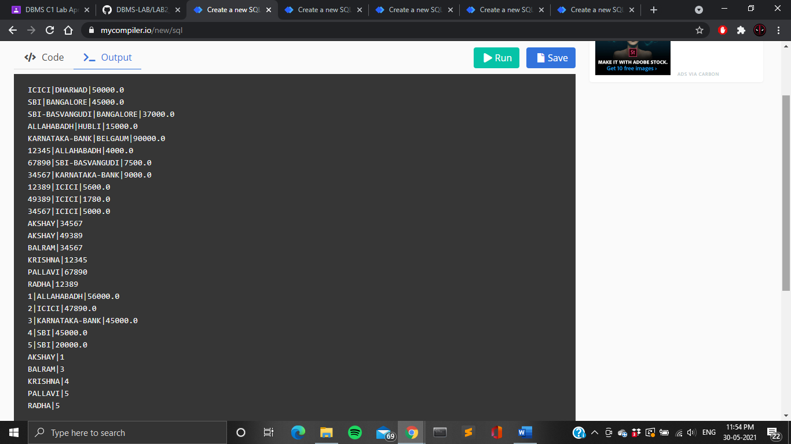









* 1. Find all the customers who have at least two accounts at the main branch.

**select customer_name from DEPOSITOR join ACCOUNTS on DEPOSITOR.accno=ACCOUNTS.accno where ACCOUNTS.branch_name='ICICI' group by DEPOSITOR.customer_name having count(DEPOSITOR.customer_name)>=2;**

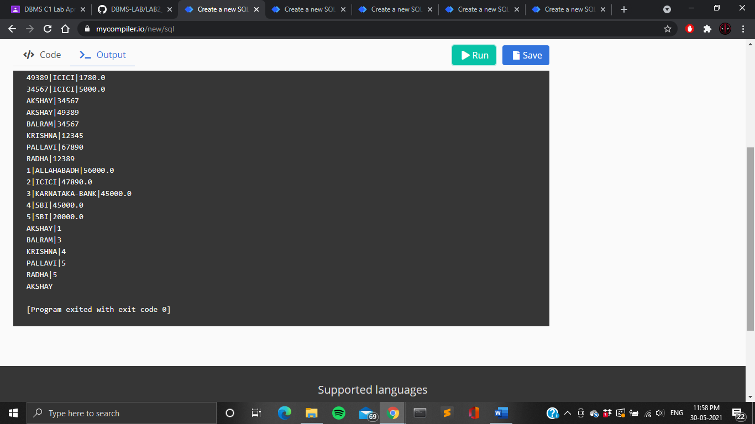

* 1. Find all the customers who have an account at all the branches located in a specific city.

**select customer_name from DEPOSITOR join ACCOUNTS on ACCOUNTS.accno=DEPOSITOR.accno join BRANCH on**

**BRANCH.branch_name=ACCOUNTS.branch_name where BRANCH.branch_city='DHARWAD' GROUP BY DEPOSITOR.customer_name**

**having count(DISTINCT BRANCH.branch_name)=(SELECT COUNT(branch_name) FROM BRANCH where branch_city='DHARWAD');**

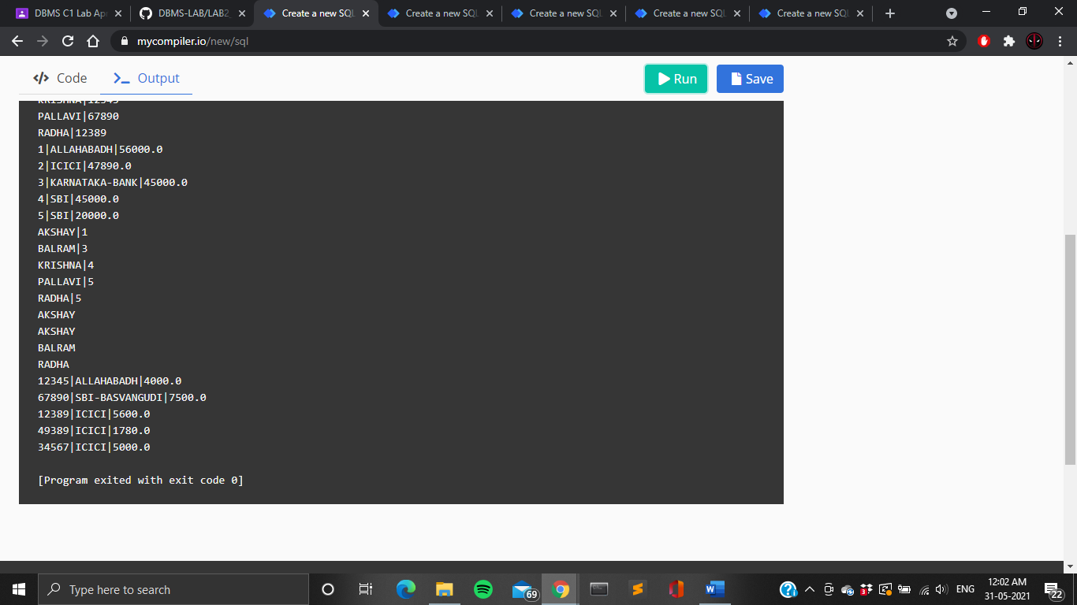

* 1. Demonstrate how you delete all account tuples at every branch located in a specific city.

**DELETE FROM ACCOUNTS WHERE branch_name in (select branch_name from BRANCH where branch_city='BELGAUM');**

